Village of Firth
Building A Deck
For Your Home Guidelines
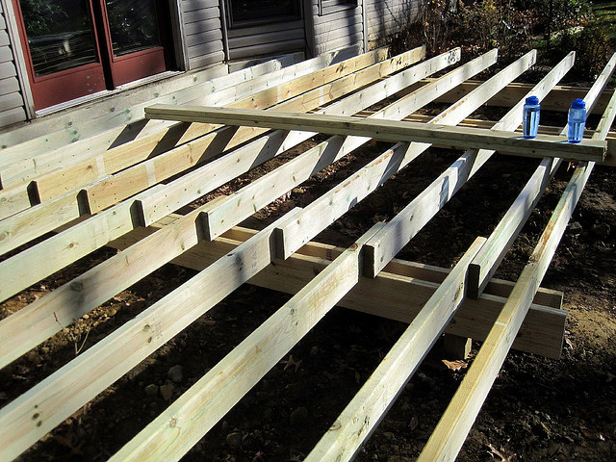
Building a deck for your home can and should be a rewarding experience. These guidelines will help ensure that building your deck is just that – a rewarding experience. All new and replacement decks require a building permit. There are two basic requirements from the City’s Department of Building and Safety to obtain a permit. A site plan shows where you want to build your deck, complete with lot dimensions and setback distances from the proposed deck to the property lines. Building and Safety also needs to know how you are building your deck. These guidelines will provide you with the minimum information necessary to obtain a deck permit.
Specific requirements for all decks:
Decks exposed to the weather must be constructed of wood resistant to decay. This would include pressure treated wood, cedar or redwood in accordance with the Building Code. Decks more than 30" above the adjacent ground must have a guard railing at least 36" in height. Stair railing is also required on at least one side of the stairs when there are more than three risers. The stair railing must be no greater than 38" above the nose of the stair tread.
A deck attached to a home must be supported by the existing home and/or frost-free footings at least 36" in depth.
Posts supporting decks must rest on top of and be connected to the footing. Posts are not permitted to be buried in the ground or footing.
Decks must be designed to support their own weight (10 lbs/sq. ft.) and the weight of objects and people (40 lbs/sq. ft.). If a hot tub is placed on the deck, an additional 50 lbs/sq. ft. will be added to the load.
The spacing of the railing balusters cannot allow the passage of a 5" sphere through any part of the railing, including the stair railing. Deck stair risers must be uniform and cannot exceed 7 3/4" in height. The riser height cannot vary more than 3/8" in a flight of stairs.
The minimum tread depth is 10”. The greatest tread depth within a flight of stairs cannot exceed the smallest by more than 3/8".
Stair treads must be reasonably level, with consideration given to shed water, snow and ice.
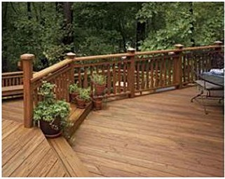

The ledger board attached to the house must be bolted to solid wood framing members.
The handgrip portion of a stair railing cannot be less than 1-1/4" or more than 2-5/8" in length. A 2x4 installed vertically is acceptable.
Floor joists may not extend (cantilever) more than 24" over the beam. Beams or headers may not extend (cantilever) more than 12" from the post.

ZONING -
The deck may project 10 feet into the rear yard setback but no closer than 5 feet from the rear property line. The Zoning Administrator can tell you the zoning setbacks for your lot.
Uncovered porches, decks or projections higher than 30 inches above grade, may project off the first story, and may extend 10 feet into the rear yard minimum setback, but in no event closer than five feet to the rear property line.

INSPECTIONS
Inspections will be done by the Village of Firth’s Building Inspector. The Foundation will be inspected first. The Framing and Final inspections will be combined and carried out when the deck is completed. When the permit is approved, you will be given a contact number for the inspector.

PLEASE NOTE:
Prior to Digging please call the Nebraska One Call System at 811
or 800.331.5666 or email your request to www.ne1call.com
at least 2 business days prior to digging but not more than 10 business days.

