
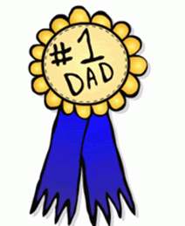

Kid’s Creations Workshop
Just for Dad!
Show Dad how awesome he is
with a gift he can use and love.

Kid Creations Registration Form:

Child’s Name ___________________________ Age ______

Child’s Name ___________________________ Age ______

Child’s Name ___________________________ Age ______

Parent’s Name(s) __________________________________

Address __________________________________________

Phone Number ____________________________________

Email address _____________________________________

Select your timeslot: ____ 10:30am – 11:30am
____ 11:30am – 12:30pm

____ $10 Payment enclosed

To volunteer at the event, contact Sally Jarecke at
402.791.2469. Email your registration to
sally.jarecke@gmail.com, or it can be dropped off in
the Village Bill Drop Box at the Firth Community Center
front doors, or mailed to:

FACET
PO Box 38
Firth, NE 68358

Sponsored by FACET
(Firth Area Community Enrichment Team)

Saturday, June 13
Firth Community Center
Cost: $10
Snack provided by:
Lakeview Assisted Living

PRE-REGISTRATION IS REQUIRED

Recommended for ages 3 and up

Crafters must be able to draw, cut, glue, paint, etc. with minimal assistance.

Parents can drop off their children for 1 hour of supervised crafting!

